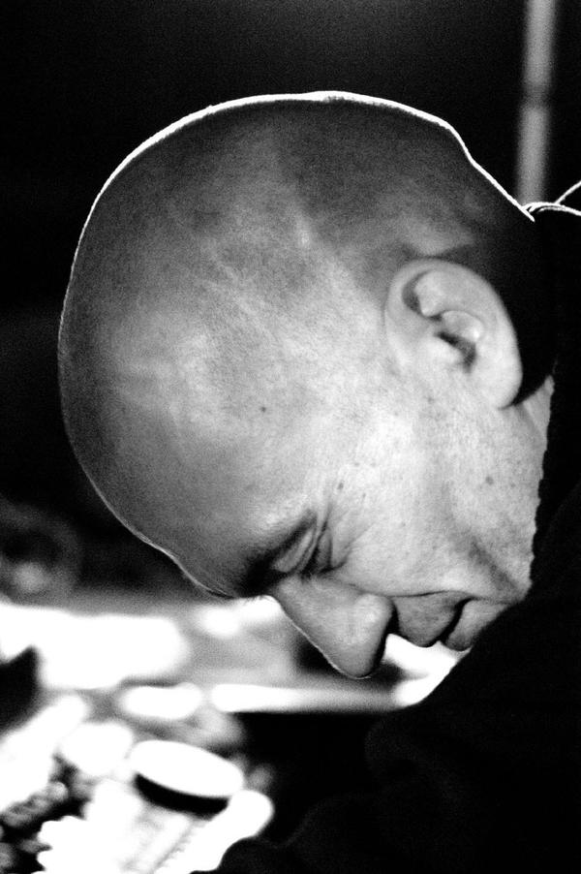

HELMUT SCHÄFER
* 14.08.1969 ― † 20.04.2007

●

noise as a language

“ So the point is that so much words existing,
and we get better and better to use them for
hiding the truth. You can use sound in the
same way, stimulating some nice and warm feeling in middle of chaos, but from time to time we all should stimulate strictness, clearness, intensity, directness, set free some anger to
bring up the basic truth of our present. Noise
can be seen as the chance to go into the back
of things, as a therapy which is able to confront ourselves with others lesser good looking sides
of life without getting frustrated by this. See it
as a source of very special energies, it gives power to see more clear and swim against. ”
(HELMUT SCHÄFER)

●

WE MISS YOU

